**React**

**9. ReactJS-HOL - Create a React Application named “cricketapp”**

**CODE:**

**Src 🡪 components**

**IndianPlayers.js**

import React from 'react';  
  
const IndianPlayers = () => {  
 const team = ["Sachin", "Dhoni", "Virat", "Rohit", "Yuvraj", "Raina"];  
 const [first, second, third, fourth, fifth, sixth] = team;  
  
 const T20Players = [  
 "First Player",  
 "Second Player",  
 "Third Player",  
 "Fourth Player",  
 "Fifth Player",  
 "Sixth Player",  
 ];  
  
 return (  
 <div>  
 <h2>Odd Players</h2>  
 <ul>  
 <li>First : {first}1</li>  
 <li>Third : {third}3</li>  
 <li>Fifth : {fifth}5</li>  
 </ul>  
  
 <h2>Even Players</h2>  
 <ul>  
 <li>Second : {second}2</li>  
 <li>Fourth : {fourth}</li>  
 <li>Sixth : {sixth}6</li>  
 </ul>  
  
 <h2>List of Indian Players Merged:</h2>  
 <ul>  
 {T20Players.map((p, i) => (  
 <li key={i}>Mr. {p}</li>  
 ))}  
 </ul>  
 </div>  
 );  
};  
  
export default IndianPlayers;

**ListofPlayers.js**

import React from 'react';  
  
const ListofPlayers = () => {  
 const players = [  
 { name: "Jack", score: 50 },  
 { name: "Michael", score: 70 },  
 { name: "John", score: 40 },  
 { name: "Amin", score: 61 },  
 { name: "Elisabeth", score: 61 },  
 { name: "Sachin", score: 95 },  
 { name: "Dhoni", score: 100 },  
 { name: "Virat", score: 84 },  
 { name: "Jadeja", score: 64 },  
 { name: "Raina", score: 75 },  
 { name: "Rohit", score: 80 },  
 ];  
  
 const lowScorers = players.filter(player => player.score < 70);  
  
 return (  
 <div>  
 <h2>List of Players</h2>  
 <ul>  
 {players.map((player, index) => (  
 <li key={index}>Mr. {player.name} {player.score}</li>  
 ))}  
 </ul>  
  
 <h2>List of Players having Scores Less than 70</h2>  
 <ul>  
 {lowScorers.map((player, index) => (  
 <li key={index}>Mr. {player.name} {player.score}</li>  
 ))}  
 </ul>  
 </div>  
 );  
};  
  
export default ListofPlayers;

**App.js**

**When const flag = true**

import React from 'react';  
import ListofPlayers from './components/ListofPlayers';  
import IndianPlayers from './components/IndianPlayers';  
  
function App() {  
 const flag = true;  
  
 return (  
 <div className="App">  
 {flag ? <ListofPlayers /> : <IndianPlayers />}  
 </div>  
 );  
}  
  
export default App;

**When const flag = false**

import React from 'react';  
import ListofPlayers from './components/ListofPlayers';  
import IndianPlayers from './components/IndianPlayers';  
  
function App() {  
 const flag = false;  
  
 return (  
 <div className="App">  
 {flag ? <ListofPlayers /> : <IndianPlayers />}  
 </div>  
 );  
}  
  
export default App;

**OUTPUT:**

**When const flag = true**

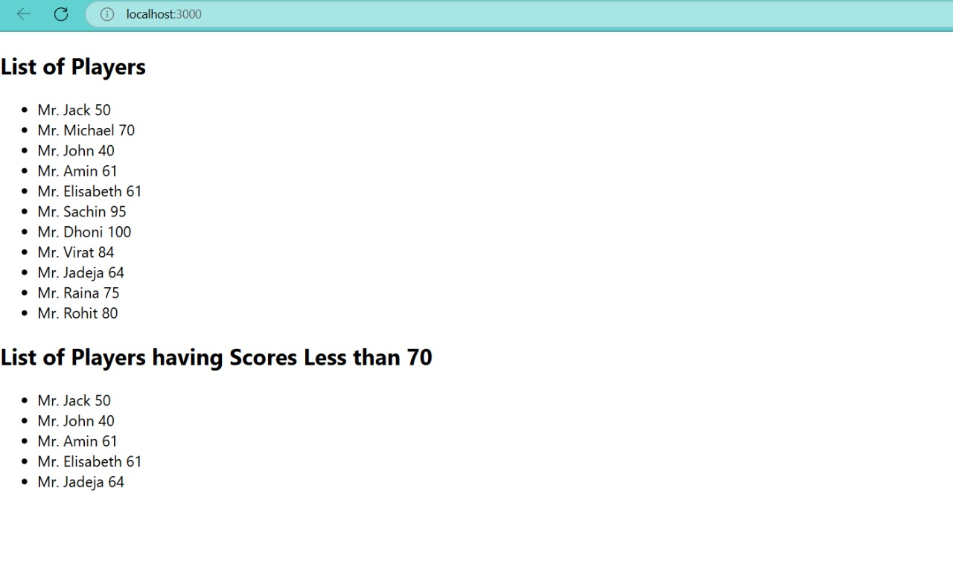

**When const flag = false**

